OBJECT ORIENTED PROGRAMMING

Fundamental

### Exercise 1:

What do each of the keywords of the following method signature mean?

|  |  |
| --- | --- |
| **public** | 访问控制修饰符，可以公开使用的 |
| **static** | 关键字静态方法 |
| **void** | 返回类型为空 |
| **String[] args** | 传入参数及类型 字符串数组 |

### Exercise 2:

Examine the following simple relationship in the following diagram:

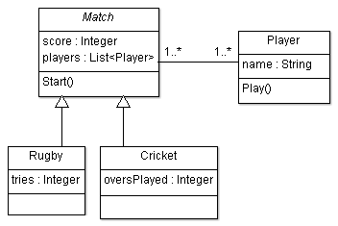

|  |  |
| --- | --- |
| **a. What type of diagram is this?** | UML  The above diagram is a UML Class Diagram |
| **b. What is the relationship between *Rugby* and *Match*?** | Generalization继承 |
| **c. What is the multiplicity between *Match* and *Player*?** | Association关联 |
| **d. What *type* of class do you think Match is likely to be?** | Match could be an abstract class. Concrete classes |

### Exercise 3:

The following UML class diagram describes a way to model sea ports and large ships. We’ll be examining this example in detail as it includes the association, aggregation, composition and interface relationships.

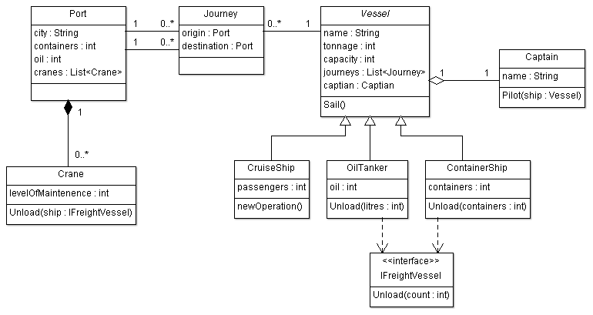

Answer the following questions: -

1. Name two classes that have an Association relationship­­­­­
2. Name two classes that have an Aggregation relationship
3. Name two classes that have a Composition relationship
4. Name a class that Implements an interface
5. Name a class that extends another class (i.e. name a subclass)
6. Identify one abstract class
7. List all Attributes of the OilTanker class (including inherited ones)
8. Reference types are the different variable types that can be used to refer to an object and are related to polymorphism. What reference types can be used to refer to a ContainerShip object?

### Exercise 4:

You have been hired by a restaurant to build them a point of sales system. The restaurant makes both food and drink by using local ingredients. Your manager tells you they want to keep track of all the different food and drink items they sell on their menu, as well as the ingredients required for each item. Both food and drink should have dietary notes (such as “may contain traces of nuts”) as well as a price. Drinks carry an extra service charge which must be captured separately. Food needs to have a course (entrée, main, dessert). The menu changes periodically and the system you design will need to keep track of this. You will also need to keep track of stock levels for ingredients. An ingredient could be used for either a drink or food.

Next, your boss asks if you can extend the system to handle reservations. They don’t care too much about who has made the booking apart from their phone number. They want to keep track of the table number for the reservation. At the end of the meal, your boss needs to be able to calculate the bill for the table, based on what the customer ordered.